Green Market Exposition, Greenburbs &
City Lights Gallery are proud to present:

The Recycled Frisbee Auction
to benefit
Green Team Bridgeport

Pre-event showing
April 22nd 2010
37 Markle Court, Bridgeport CT 06604-4816

(Auction will be held at the Barnum Museum during the Green Market Exposition Oct 8 & 9 , 2010)
Dear Artists,

I thereby agree to return this recycled plastic Frisbee with art work painted on its surface, in time to be put up for auction at the next Green Market Exposition.

Name: ____________________________________
Address: __________________________________

___________________________________________

Email: _____________________________________

Phone Number: ___________________________
Sponsored by:

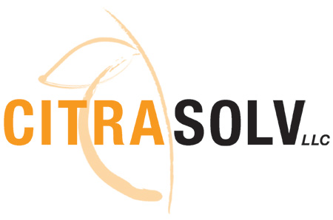
The Frisbee was invented in Bridgeport, a pastime at the Frisbie Pie Tin Company. We are celebrating it as a symbol of innovation and technological excellence to represent the City of Bridgeport in the emerging green economy.
Return painted Frisbees by mail to:
Remy Chevalier, 25 Newtown Turnpike, Weston CT. (203-227-2065)
